**PROJECT-1**

**Name:** Para Pavani

**Course:** AWS DevOps

**Project Name:** Three-Tier Architecture in AWS

**Contact No:** +91 7075065254

**Email:** [pavanipara994@gmali.com](mailto:pavanipara994@gmali.com)

**INTRODUCTION OF 3-TIER ARCHITECTURE**

The three-tier architecture is a widely used implementation of a multi-tier architecture, consisting of three layers: the presentation tier, application tier, and database tier.

1. **Presentation Tier**: This layer displays information to users and collects their inputs through user interface components such as web pages and forms.
2. **Application Tier**: Also known as the logic tier, this layer processes user inputs from the presentation tier, applying business logic to create, display, modify, and store data. It often includes application servers and microservices.
3. **Database Tier**: Also called the data tier or back-end, this layer stores and manages information processed by the application tier, ensuring data consistency and integrity.

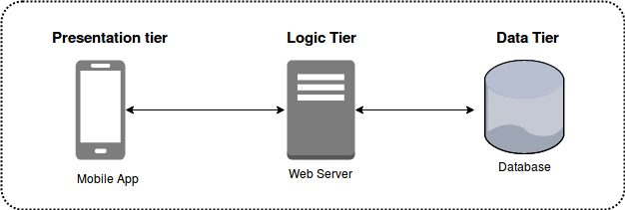**Benefits**: Scalability, Reliability, Security, Flexibility

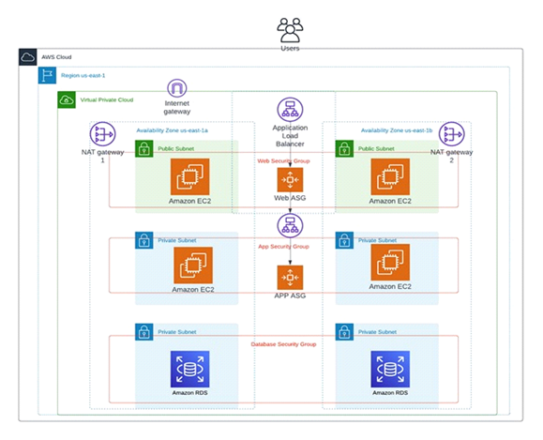**ARCHITECTURE:**

**Virtual Private Cloud (VPC) :**

A Virtual Private Cloud (VPC) provides full control over your virtual networking environment, including resource placement, connectivity, and security. The purpose of a VPC is to create a secure, isolated private cloud within a public cloud.

**Steps to Create a VPC and Its Components**

* Creating a VPC
* Subnets: Public and private
* Internet Gateway
* Route Tables
* NAT Gateway

**Architecture Requirements**

* Create a VPC.
* Create 2 public subnets in 2 availability zones.
* Create 4 private subnets in 2 availability zones.

**Create VPC**

* Click on "Create VPC".
* Select "VPC only".
* Provide a name for your VPC.
* Enter the IPv4 CIDR block.
* 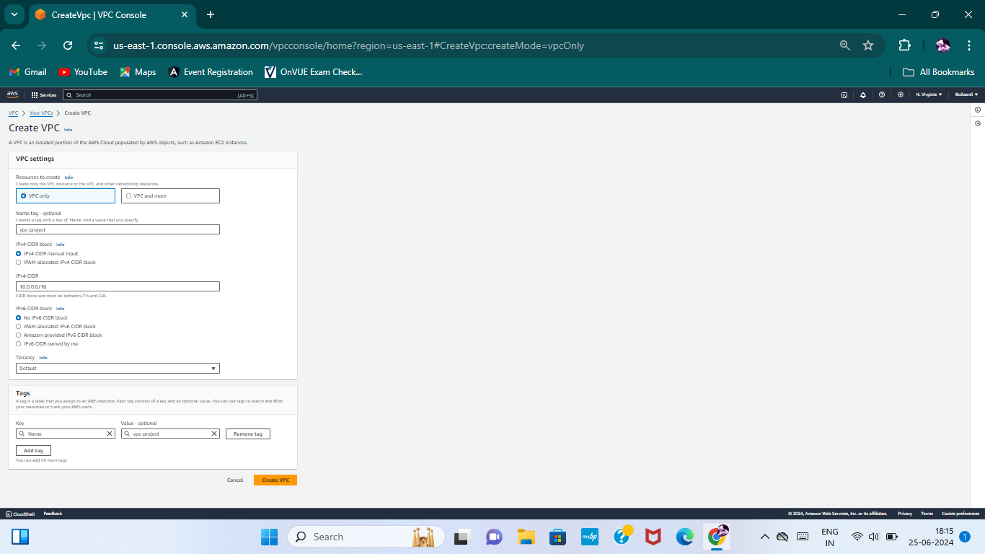Click on "Create VPC".

**Subnet:**

A subnet is a range of IP addresses within your VPC. You launch AWS resources, such as Amazon EC2 instances, into your subnets. You can connect a subnet to the internet, other VPCs, and your own data centers.

**Steps to Create Subnets**

**Requirements**

* Create 6 subnets: 2 public subnets in 2 availability zones and 4 private subnets.
* 2 private subnets in 1a zone for autoscaling.
* 2 private subnets in 1b zone for the database.

**Create Subnets**

* Go to "Subnets" in the VPC dashboard.
* Click on "Create subnets".
* Select your VPC.
* Provide a name for the subnet.
* Select the availability zone.
* Enter the IPv4 CIDR block for the subnet.
* Click on "Add subnets".

**Repeat for Additional Subnets**

* Click on "Add subnets" and repeat the process to create the remaining 5 subnets.
* Ensure to distribute the subnets across the specified availability zones.
* Click on "Create subnets" once all required subnets are added.

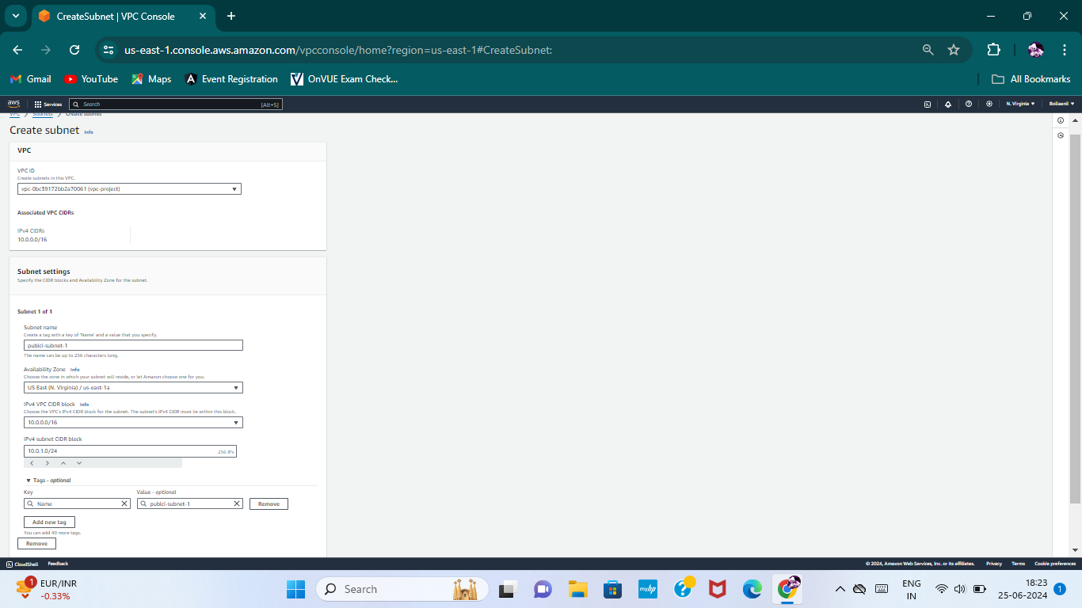

* Here all subnets are successfully created.

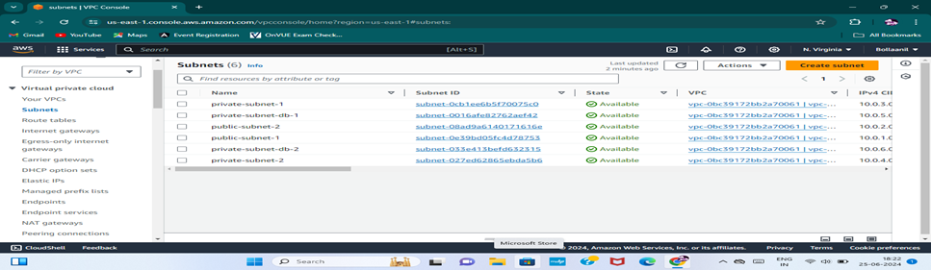

**Internet Gateway:**

An internet gateway provides two-way public connectivity to applications running in AWS Regions or Local Zones. It enables you to connect to an EC2 instance in AWS using your local computer.

**Steps to Create and Attach an Internet Gateway**

**Create an Internet Gateway**

* Go to the VPC dashboard.
* Click on "Internet Gateways" in the left navigation pane.
* Click on "Create Internet Gateway".
* Provide a name for the internet gateway.
* Click on "Create internet gateway".

**Attach the Internet Gateway to Your VPC**

* After creating the internet gateway, select it from the list.
* Click on "Actions" and then "Attach to VPC".
* 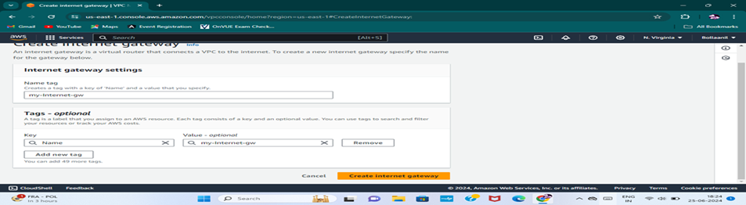Select your VPC from the list and click "Attach internet gateway".

**NAT Gateway:**

NAT stands for Network Address Translator. It is a highly available AWS managed service that makes it easy to connect to the Internet from instances within a private subnet in an Amazon VPC.

**Steps to Create a NAT Gateway**

* Click on "Create NAT Gateway".
* Provide a name for the NAT gateway.
* Select one of your public subnets for the NAT gateway.
* Click on "Allocate Elastic IP" to assign an Elastic IP address.
* Click on "Create NAT Gateway".
* 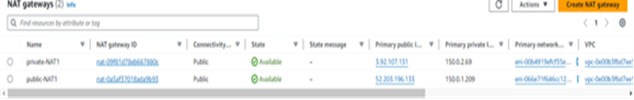Repeat the above steps to create the second NAT gateway in a different public subnet for high availability.

**Route Table :**

A route table contains a set of rules, called routes, that determine where network traffic from your subnet or gateway is directed. It is used to determine which way to forward traffic.

**Create PRoute Table**

* Go to the VPC dashboard.
* Click on "Route Tables" in the left navigation pane.
* Click on "Create route table".
* Provide a name for the route table (e.g., "Public Subnet Route Table").
* Select your VPC from the dropdown menu.
* Click on "Create route table".
* Repeat the above steps to create another route table that is” Private Subnet Route Table” and "Database Subnet Route Table".

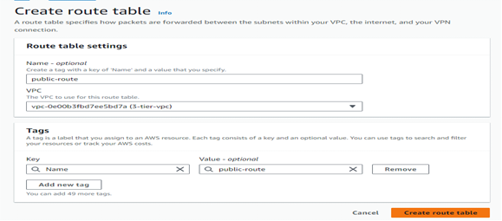

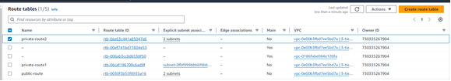

**Launch EC2 Instances**

**Launch an Instance**

* Click on "Launch instance".
* Provide a name for your instance.

**Edit Network Settings**

* Scroll down to "Network settings".
* Click on "Edit".
* Select your VPC from the "Network" dropdown.
* Choose one of your public subnets from the "Subnet" dropdown.
* Enable "Auto-assign public IP" by selecting the checkbox.

**Configure Security Groups**

* In the "Configure security group" section, click on "Create security group".
* Provide a name and description for the security group.
* Add the following inbound rules:
* HTTP: Allow HTTP traffic (port 80) from anywhere (0.0.0.0/0).
* MYSQL/Aurora: Allow MySQL/Aurora traffic (port 3306) from your specific IP or a specific range of IPs for secure access.
* 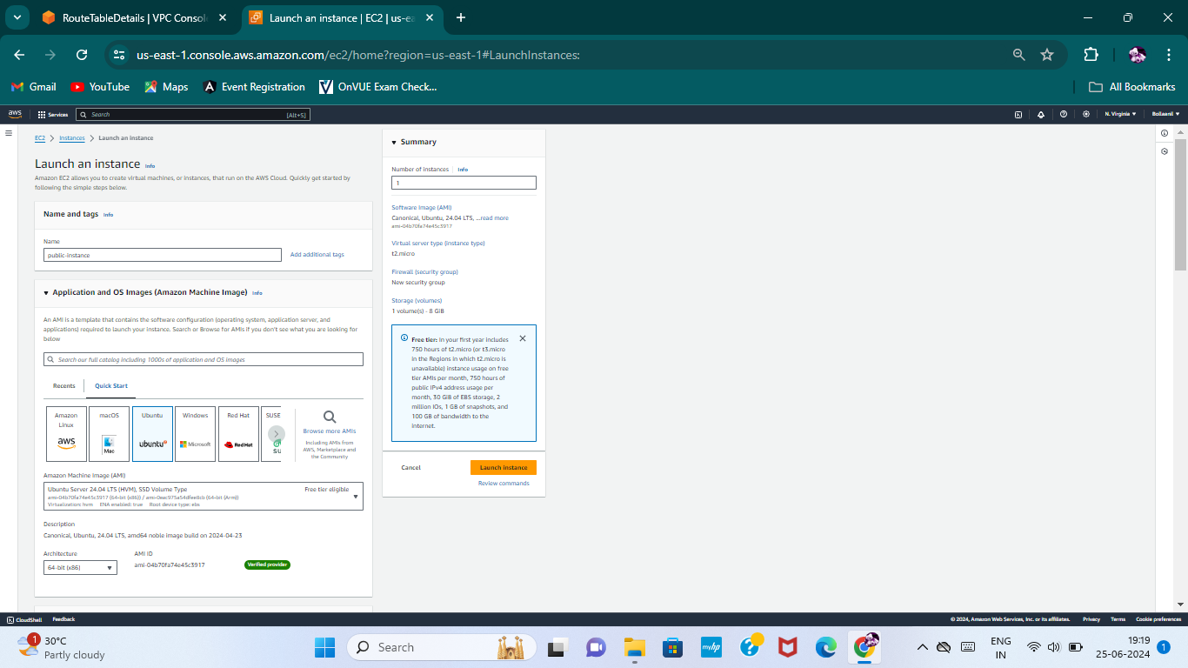Click on "Launch instance".
* After that to create Launch Template for instnaces
* Select your instance go with image and templates
* Click on create template from instance
* Give naming and create launch template

**Create a Target Group**

Creating a target group allows you to route requests to one or more registered targets, such as EC2 instances, using a load balancer. Follow these steps to create a target group:

**Create Target Group**

* Click on "Create target group".
* Provide a name for your target group.
* Choose the VPC in which your instances are running.
* Click "Next".
* Select the instances you want to include in the target group.
* Click on "Create target group".

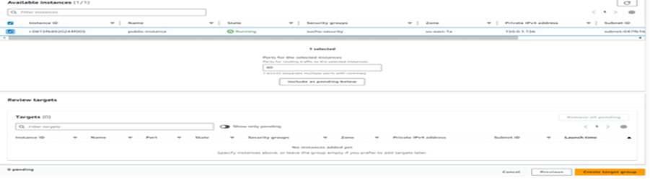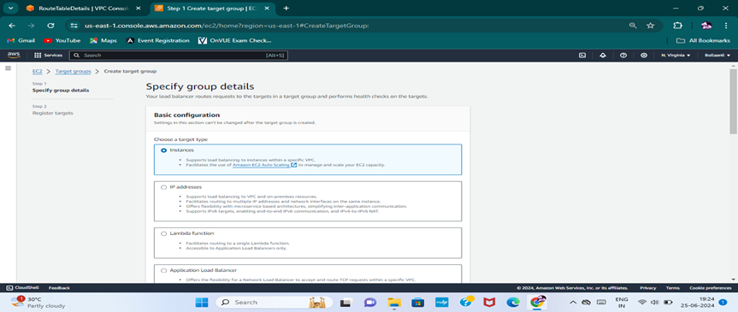

**Create a Load Balancer**

Load balancers distribute incoming application traffic across multiple targets, such as EC2 instances, in multiple availability zones. Follow these steps to create an “Application Load Balancer”.

**Create Load Balancer**

* Click on "Create Load Balancer".
* Select "Application Load Balancer".
* Provide a name for your load balancer.
* Choose your VPC.
* In the "Mappings" section, select the public subnets to be used.
* Select the security group for your load balancer.
* Select the target group that you created earlier.
* 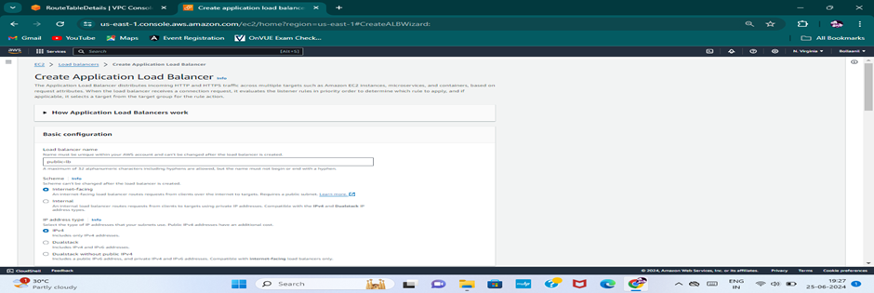Click on "Create Load Balancer".
* Now go to Ec2 service and select Auto Scaling group.
* Click on Create Auto Scaling group.
* Give name tag Auto Scaling group name for public.
* Select your public launch template and click on next.
* In network settings select your VPC and select two public subnets click on next.
* In configure group size and scaling enter desired capacity, click on next.
* Click on Create Auto scaling.

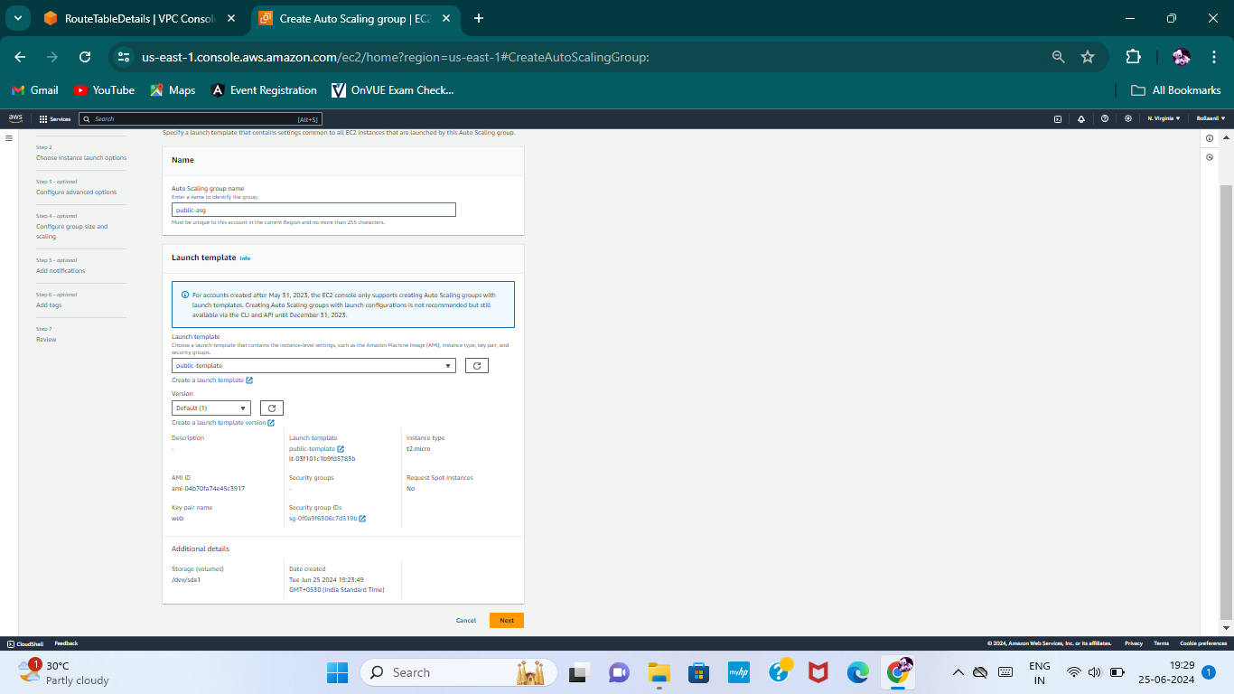

* Same as it is, you need launch another instance which is "private".
* 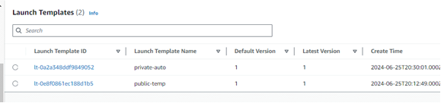Create another template "private" and attach to private instance.
* 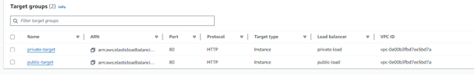Create another Target group "private".
* Create another load balancer "private".
* Create another Auto-Scaling.
* Attach private Subnets 2.

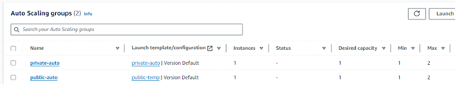

**Create Subnet Group:**

RDS stands for Relational database service and it is an easy-to-manage relational database service optimized for total cost of ownership.

RDS DB subnet group is a collection of subnets that are associated with an Elastic Compute Cloud(Ec2) and Virtual private cloud(VPC).

* Now go to search bar and search RDS
* Now you need to create subnet group
* An RDS Subnet Group is a collection of subnets that you can use to designate for your RDS database instance in a VPC.
* 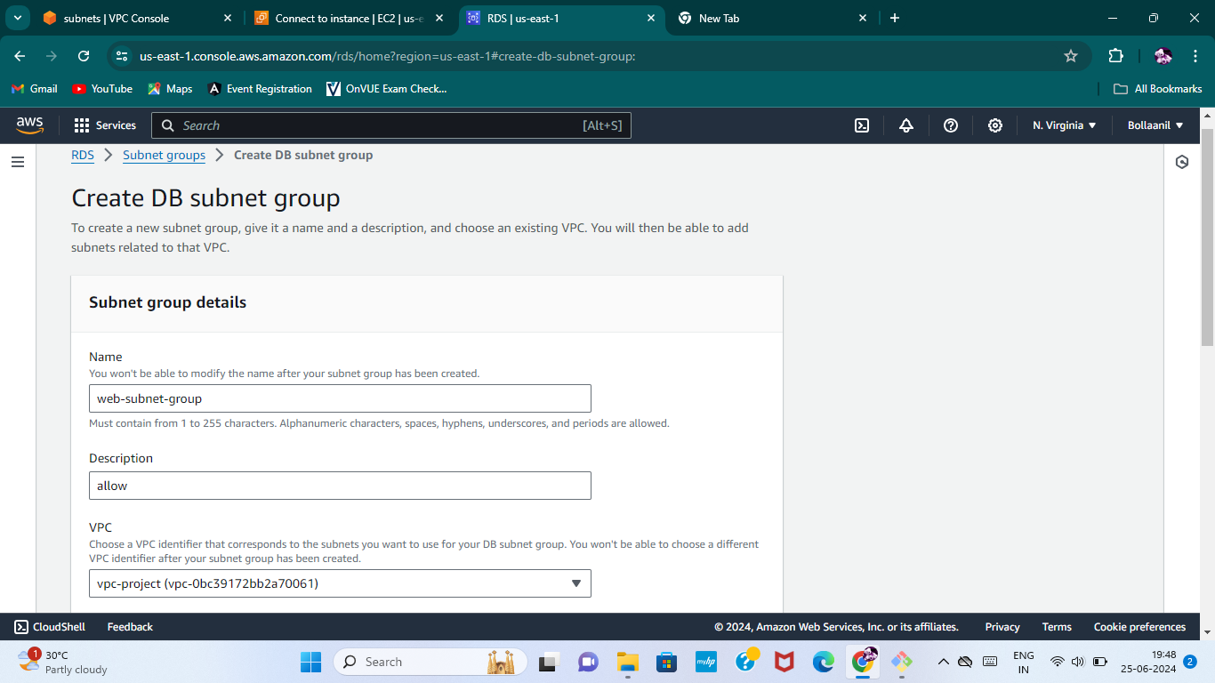Click on create subnet group and enter the name, choose your VPC
* Select your Availability Zones.
* Add subnets using private subnets and select private subnets
* Click on create.

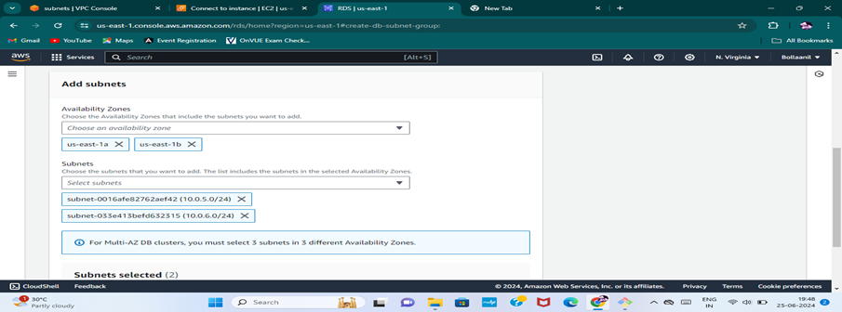

**Create RDS:**

* Go to database and click on create database
* Select a database creation method is "standard create"
* Select “MySql” engine type and select free tier template.
* Enter name for your DB cluster and enter master username.
* Select credentials management is "slef managed" and enter your own password.
* 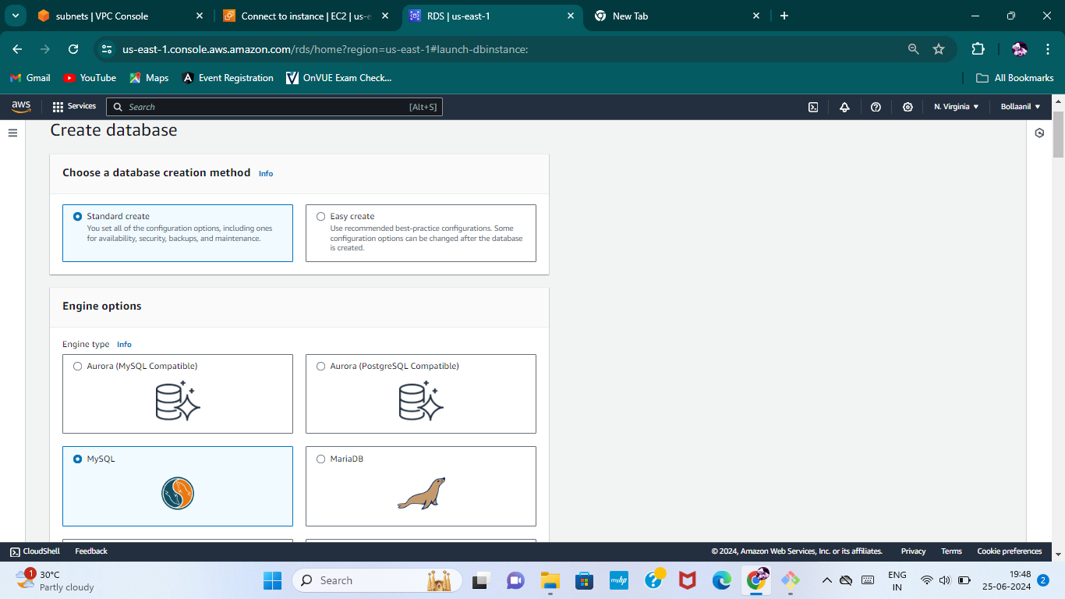In connectivity select your VPC and security group and click on create database.
* Go to ec2 instance click on public instance and connect it.
* Now in public instance you have to connect private instance.

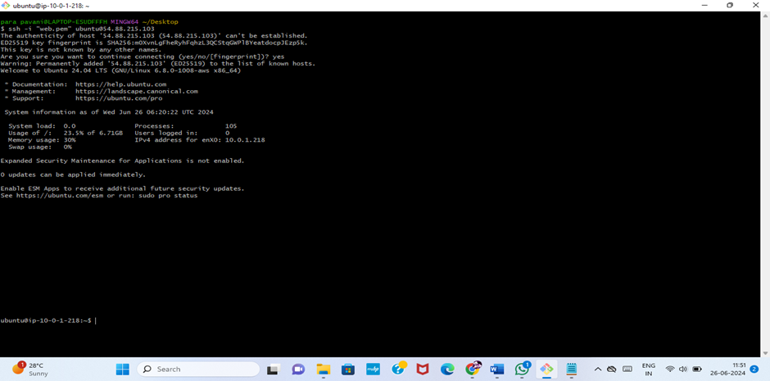

* You have to install MYSQL
* First you need update for that enter "apt update -y"
* To install MYSQL enter the command is "apt install mysql-server"
* To start the MYSQL enter the command is "systemctl start mysql.service"
* To connect database enter the command is mysql -h <database endpoint> -u <master username> -p
* Enter your password
* 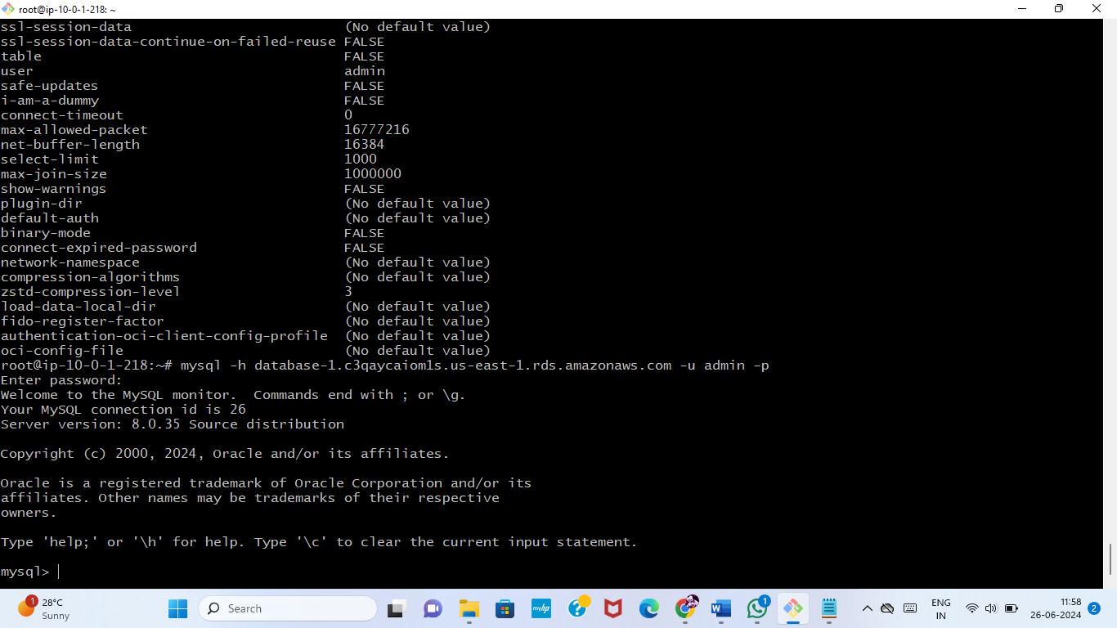So finally “mysql” server is connected.

**Conclusion:**

The 3-tier architecture offers a robust and scalable framework for modern applications by separating them into presentation, application, and data layers. We effectively designed and implemented a scalable, secure, and efficient 3-tier architecture on Amazon Web Services for web applications.